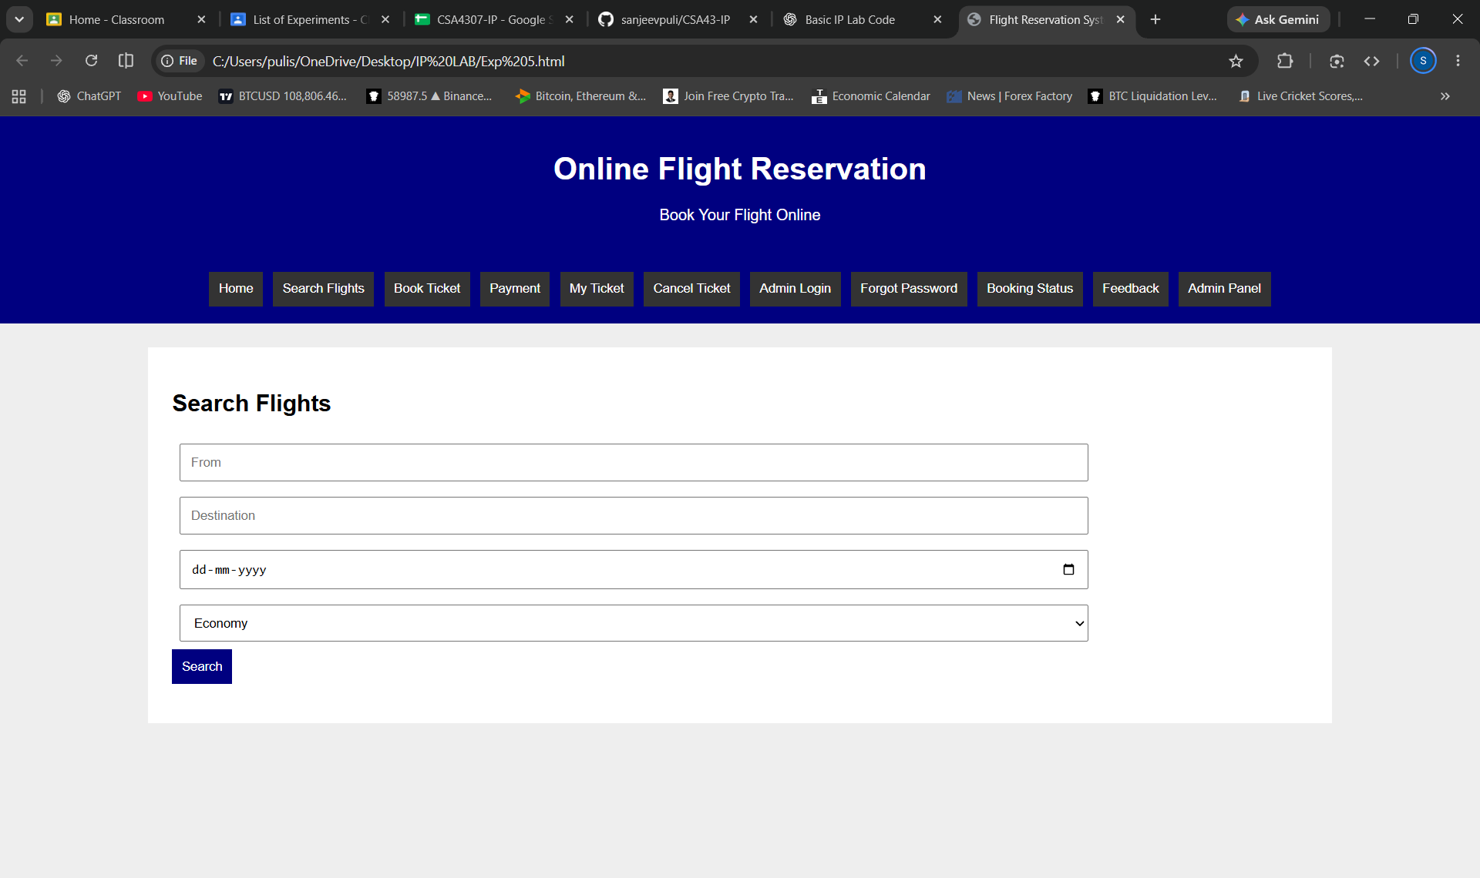
<!DOCTYPE html>
<html>
<head>
<title>Flight Reservation System</title>
<style>
body{font-family:Arial;margin:0;background:#eee}
header,nav{background:navy;color:white;text-align:center;padding:15px}
nav button{background:#333;color:white;border:0;padding:10px;margin:3px;cursor:pointer}
.box{background:white;margin:25px auto;padding:25px;width:80%;box-sizing:border-box}
input,select,textarea{padding:10px;margin:8px;width:80%;box-sizing:border-box}
button{padding:10px;background:navy;color:white;border:0;cursor:pointer}
.page{display:none}
#home{display:block}
</style>
</head>
<body>

<header>
<h1>Online Flight Reservation</h1>
<p>Book Your Flight Online</p>
</header>

<nav>
<button onclick="show('home')">Home</button>
<button onclick="show('search')">Search Flights</button>
<button onclick="show('booking')">Book Ticket</button>
<button onclick="show('payment')">Payment</button>
<button onclick="show('ticket')">My Ticket</button>
<button onclick="show('cancel')">Cancel Ticket</button>
<button onclick="show('login')">Admin Login</button>
<button onclick="show('forgot')">Forgot Password</button>
<button onclick="show('status')">Booking Status</button>
<button onclick="show('feedback')">Feedback</button>
<button onclick="show('admin')">Admin Panel</button>
</nav>

<div class="box page" id="home">
<h2>Welcome to Flight Reservation</h2>
<p>Search flights, book tickets and manage your journey easily.</p>
</div>

<div class="box page" id="search">
<h2>Search Flights</h2>
<input id="from" placeholder="From">
<input id="to" placeholder="Destination">
<input type="date" id="date">
<select id="class">
<option>Economy</option>
<option>Business</option>
<option>First Class</option>
</select><br>
<button onclick="searchFlight()">Search</button>
<p id="flightResult"></p>
</div>

<div class="box page" id="booking">
<h2>Book Flight Ticket</h2>
<input id="name" placeholder="Passenger Name">
<input id="flight" placeholder="Flight Name">
<input type="number" id="passengers" placeholder="Number of Passengers">
<button onclick="bookTicket()">Book Ticket</button>
<p id="bookResult"></p>
</div>

<div class="box page" id="payment">
<h2>Ticket Payment</h2>
<input placeholder="Cardholder Name">
<input placeholder="Card Number">
<input type="month">
<button onclick="pay()">Pay Now</button>
<p id="payResult"></p>
</div>

<div class="box page" id="ticket">
<h2>My Ticket</h2>
<input id="ticketNo" placeholder="Enter Booking ID">
<button onclick="viewTicket()">View Ticket</button>
<button onclick="window.print()">Print Ticket</button>
<p id="ticketResult"></p>
</div>

<div class="box page" id="cancel">
<h2>Cancel Ticket</h2>
<input id="cancelNo" placeholder="Enter Booking ID">
<button onclick="cancelTicket()">Cancel Ticket</button>
<p id="cancelResult"></p>
</div>

<div class="box page" id="login">
<h2>Administrator Login</h2>
<input placeholder="Username">
<input type="password" placeholder="Password">
<button onclick="alert('Login submitted')">Login</button>
</div>

<div class="box page" id="forgot">
<h2>Forgot Password</h2>
<input type="email" placeholder="Enter Email">
<button onclick="alert('Password reset request submitted')">Reset Password</button>
</div>

<div class="box page" id="status">
<h2>Booking Status</h2>
<input id="statusNo" placeholder="Enter Booking ID">
<button onclick="checkStatus()">Check Status</button>
<p id="statusResult"></p>
</div>

<div class="box page" id="feedback">
<h2>Customer Feedback</h2>
<input id="customer" placeholder="Your Name">
<textarea id="message" placeholder="Enter Feedback"></textarea><br>
<button onclick="feedback()">Submit Feedback</button>
<p id="feedbackResult"></p>
</div>

<div class="box page" id="admin">
<h2>Admin Panel</h2>
<input id="airline" placeholder="Airline Name">
<input id="seats" type="number" placeholder="Available Seats">
<input id="fare" type="number" placeholder="Ticket Fare">
<button onclick="updateFlight()">Update Flight</button>
<button onclick="alert('Admin Report Generated')">Admin Report</button>
<p id="adminResult"></p>
</div>

<script>
let bookingID="";

function show(id){
document.querySelectorAll('.page').forEach(p=>p.style.display='none');
document.getElementById(id).style.display='block';
}

function searchFlight(){
let f=document.getElementById('from').value;
let t=document.getElementById('to').value;
let d=document.getElementById('date').value;
document.getElementById('flightResult').innerText=
f&&t&&d?'Flight: Air India | 10:00 AM | Seats Available: 25 | Fare: ₹4500':'Enter all flight details';
}

function bookTicket(){
let n=document.getElementById('name').value;
let f=document.getElementById('flight').value;
if(!n||!f){alert('Enter passenger and flight details');return;}
bookingID=Math.floor(100000+Math.random()*900000);
document.getElementById('bookResult').innerText=
'Booking Created! Booking ID: '+bookingID;
}

function pay(){
document.getElementById('payResult').innerText=
'Payment successful (Demo).';
}

function viewTicket(){
let id=document.getElementById('ticketNo').value;
document.getElementById('ticketResult').innerText=
id?'Flight Ticket | Booking ID: '+id+' | Status: Confirmed':'Enter Booking ID';
}

function cancelTicket(){
let id=document.getElementById('cancelNo').value;
document.getElementById('cancelResult').innerText=
id?'Ticket Cancelled (Demo)':'Enter Booking ID';
}

function checkStatus(){
let id=document.getElementById('statusNo').value;
document.getElementById('statusResult').innerText=
id?'Booking Status: Confirmed':'Enter Booking ID';
}

function feedback(){
let n=document.getElementById('customer').value;
let m=document.getElementById('message').value;
document.getElementById('feedbackResult').innerText=
n&&m?'Feedback submitted successfully':'Enter name and feedback';
}

function updateFlight(){
let n=document.getElementById('airline').value;
let s=document.getElementById('seats').value;
let f=document.getElementById('fare').value;
document.getElementById('adminResult').innerText=
n&&s&&f?'Flight Updated: '+n+' | Seats: '+s+' | Fare: ₹'+f:'Enter all details';
}
</script>

</body>
</html>

